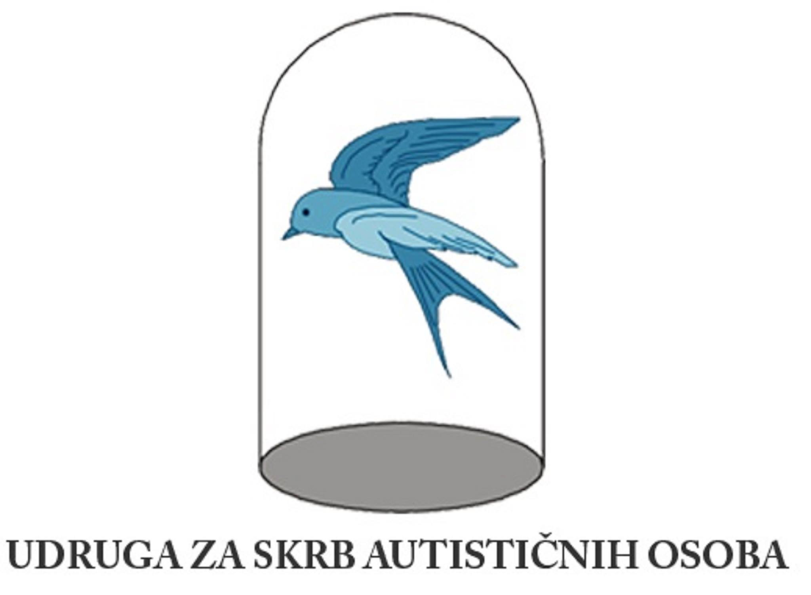
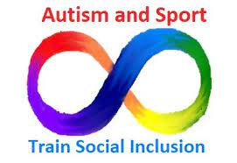

Youth Mobility Assessment Sheet

Athlete:

Trainer:

Table No.1. Example of individual curiculum for month/year plan

FIELD / SUBJECT | Topics | ACTIVITIES | EDUCATIONAL OUTCOMES | SUPPORT STRATEGIES | ACHIEVEMENT OF OUTCOMES
1.KINESITHERAPY | 1. Biotic motor knowledge  2. Influence on motor skills  3. Obstacle polygons  4. Kinesitherapy exercises | 1.1. Free walking in the given space, walking with a change of direction, crawling on your knees forward, crawling on your knees backwards, lift the medicine girl off the floor, lift the medicine girl and transfer her from the cone to the hoop  2. 1.Autism fitness program  3. 1. Polygons according to motor abilities, according to functional abilities  4.1.Exercises for the upper back and shoulders, exercises for the lower back, exercises for the torso, exercises for the feet, breathing exercises, somatic exercises | 1. The student performs the activity for up to 3 minutes  2. The student performs half of the activities with 1-3 series and 2-6 repetitions  3. The student performs activities at least 3 times in a row with or without rest  4. The student performs 2 exercises for each body part in 1-3 series with 2-6 repetitions | 1. Physical support  2. Physical and verbal guidance  3. Verbal guidance and demonstration  4. Minimum verbal support with termination until independent performance of activities  4.Picture sequence  5. Video display | +  +/-  -
2. WATER SPORT | 1. Swimming | 1.1. Exercises on dry land and in water, getting used to water, breathing exercises in place and movement, basic biotic movements in water, adapted strength and strength exercises along the edge of the pool, floating with support | 1. The student performs 4 activities in 1-3 series with 2- 6 repetitions | 1. Physical support  2. Physical and verbal guidance  3. Verbal guidance and demonstration  4. Minimum verbal support with termination until independent performance of activities  4.Picture sequence | +  +/-  -
3.OUTDOOR STAY /  HORSEBACK RIDING | 1. Hiking and trekking  2. Horseback riding | 1. Planning and hiking up to 4 km without slope and with slope  2. Elements of hippotherapy with a therapist on the riding ground | 1. The student performs the planned route regardless of the time period  2. The student performs 5 elements as part of hippotherapy | 1. Physical support  2. Physical and verbal guidance  3. Verbal guidance and demonstration  4. Minimum verbal support with termination until independent performance of activities  4.Picture sequence | +  +/-  -

Table No.1. Dates of therapies (PLANNED / ACHIEVED)
 | JANUARY | FEBRUARY | MARCH | APRIL | MAY | JUNE | SEMPTEBER | OCTOBER | NOVEMBER | DECEMBER
1.KINESITHERAPY
2. WATER SPORT
3.OUTDOOR STAY /
HORSEBACK RIDING

ADAPTED KINESITHERAPY PROGRAM
SEX:
AGE:
TESTING:
- FIRST:
- 1. TRANSITIVE:
- 2. TRANSITIVE:
- FINAL:
ANTHROPOLOGY
HEIGHT:
WEIGHT:
BODY MASS INDEX:
HAND RANGE:
BEND (sitting, standing): (support required: YES / NO)
TEST LIFTING LEGS (lying down): (support required: YES / NO)
PHYSIO OR KINESITHERAPY EXAMINATION:
ADJUSTMENTS:

Sensor systems:
vestibular (movement, balance):
propioceptive (muscles and joints):
tactile (touch):
visual (sight):
auditory (hearing):
olfactory (odor):
gustatory (taste):

Table no. 3. KINESITHERAPY / ACTIVITIES (adapted Autism fitness program)
KINESITHERAPY / ACTIVITIES  (custom Autism fitness program) | PERFORMANCES  with verbal support | PERFORMANCES with physical guidance | DO NOT PERFORM  (difficulties in  motivation,  cognitive or  physical) | NOTES
1. STANDING INSIDE THE CIRCLE
(3 sec)
SER: REP:
2.SQUAT
(BELOW PARALLEL)
SER : REP:
3. TROWING MEDICINE BALL FROM CHEST
KG: SER: REP:
4. TROWING MEDICINE BALL OVER THE HEAD
KG: SER: REP:

5. THROWING (PUSHING) MEDICINE BETWEEN LEGS
KG: SER: REP:
6.OVERHEAD PRESS WITH SANDBELL
KG: SER: REP:
7. PULLING ELASTIC BAND
KG: SER: REP:

8. HURDLE STEPS
HEIGHT: SER: REP:

9. ROPE SWING
SER: REP:
10. PULLING ROPE
SER: REP:
11.LONG JUMP
SER: REP:
12. CRAWL (variants)
SER: REP:
13. “GLUTE BRIDGE”
SER: REP:

Trough this project we work on making picture application with instructions for kinesitherapy exercises at home for children with disabilities "Cats exercise"

Possible to dowload: https://play.google.com/store/apps/details?id=com.vedran.gojkovic.micevjebaju

